School Science, Computing and Engineering Technologies

# Start of Assessment

TNE10006/TNE60006 Networks and Switching

DISCLAIMER: this assessment paper has been prepared to provide a sample of the style and content of questions students may find in the Final Written Assessment. Please note that this is an **abbreviated** paper, containing only one or two questions from each of the 8 main question categories, hence being only out of 26.5 marks.

The actual Final Written Assessment paper will contain more questions, and will typically be marked out of:

* **TNE10006** – 90 to 100 marks
* **TNE60006** – 100 to 110 marks

Q1 Consider the 802.3 Ethernet Protocol.

* 1. Do collisions occur in a switched network? Why/Why Not?

**Ans.**

No Collision occurred in a switched network. When a port of the switch receives a frame, it checks the destination address in the frame and then sends the frame to the corresponding port, for outgoing data. However, there is a still possibility of collision, if it received frames from more than on port.

(3 marks)

(3 marks)

Q2 Consider the IP Protocol

a) Answer each of the following questions TRUE or FALSE:

i. **False**------- 57.69.168.31/27 is a valid host IP address (1 mark)

ii. **True**--------205.64.87.17 is in the 205.64.87.0/26 subnet (1 mark)

b) An IP Packet of size 5,730 bytes is sent over a link with a 600-byte MTU

i. How many IP fragments are sent?

🡺 10

(1 mark)

ii. Fragment 3 is lost, will the IP layer request retransmission?

🡺No

(1 mark)

* 1. Write the following IPv6 addresses in abbreviated form:

i. 48a4:00b4:0000:0000:0000:0000:cd00:0a7b

🡺 48a4:b4::cd00:a74

(1 mark)

* 1. Consider the host with the IPv6 Address 2001:16d4:b:4:13a1:18ee:ed2b:8f7b/64

i. What is the Site Address Space ID with prefix?

🡺 **48a4:00b4::/48**

(1 mark)

(6 marks)

Q3 Question 3 is a VLSM question worth 15 marks. You should understand the type of question without a sample

Q4 This question concerns Transport Layer Protocols

a) Consider the TCP Three-Way Handshake depicted in the figure below, the sequence number of the first SYN packet is 1,543

i. How many bytes of data are contained within the first SYN Packet?

0 bytes

(1 mark)

ii. In the SYN-ACK response, what is the Acknowledgement number?

1544

(1 mark)

iii. What is the sequence number in the SYN-ACK response?

Random number

(2 marks)

iv. How many bytes of data may the sender include in the final ACK packet?

1 bytes

(1 mark)

(5 marks)

Q5 Consider the following network with assiciated IP Address, MAC Address and ARP/MAC table information

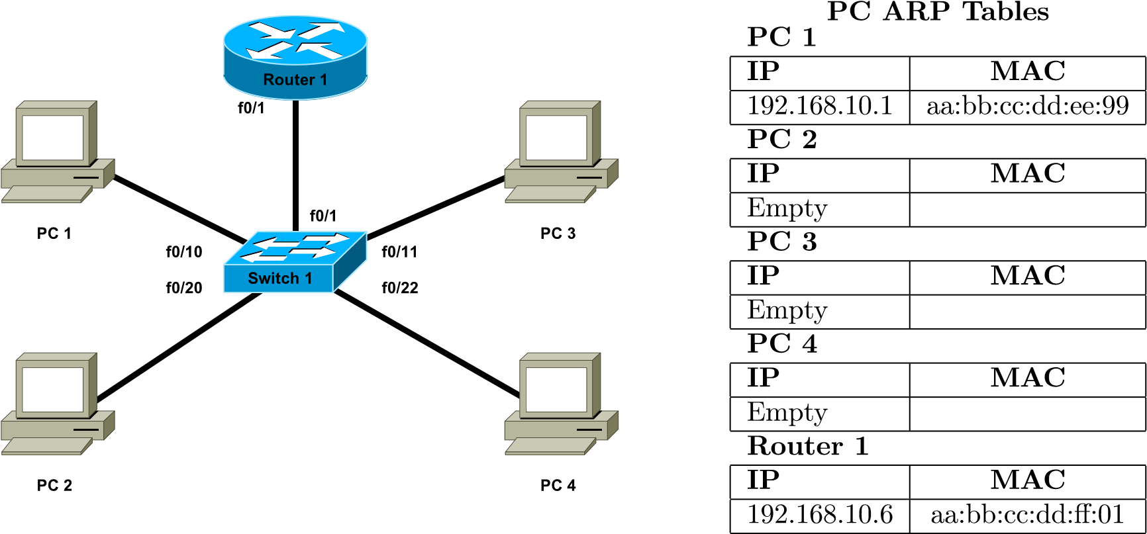

Interface Configuration Details

|  |  |  |  |  |
| --- | --- | --- | --- | --- |
| Device | Interface | VLAN | MAC | IP |
| Router 1 | f0/1.10 | 10 | aa:bb:cc:dd:ee:99 | 192.168.10.1 |
| f0/1.20 | 20 | aa:bb:cc:dd:ee:99 | 192.168.20.1 |
| f0/1.99 | 99 | aa:bb:cc:dd:ee:99 | 192.168.99.1 |
| Switch 1 | f0/1 | Trunk | – | – |
| f0/10 | 10 | – | – |
| f0/11 | 10 | – | – |
| f0/20 | 20 | – | – |
| f0/22 | 20 | – | – |
| vlan99 | 99 | aa:bb:cc:dd:00:99 | 192.168.99.5 |
| PC 1 | – | – | aa:bb:cc:dd:ff:01 | 192.168.10.6 |
| PC 2 | – | – | aa:bb:cc:dd:ff:02 | 192.168.20.7 |
| PC 3 | – | – | aa:bb:cc:dd:ff:03 | 192.168.10.8 |
| PC 4 | – | – | aa:bb:cc:dd:ff:04 | 192.168.20.9 |

|  |  |
| --- | --- |
| MAC | Port |
| aa:bb:cc:dd:ee:99 | f0/1 |
| aa:bb:cc:dd:ff:01 | f0/10 |

Switch 1 MAC Table

a) When a packet from PC1 to PC4 traverses the trunk link from Switch 1 to

Router 1, fill in the following information as seen in the packet headers

|  |  |  |
| --- | --- | --- |
|  | Source | Destination |
| MAC | **aa:bb:cc:dd:ff:01** | **aa:bb:cc:dd:ee:99** |
| IP | **192.168.10.6** | **192.168.10.1** |

(2 marks)

b) Nominate one advantage and one disadvantage of a layered network protocol architecture?

* Advantage:
  1. Layered network protocol architecture makes the communication between hosts much simpler and effective. Here different layer has different task to complete
* Disadvantage:
  1. Rdinadany in some cases



(2 marks)

(4 marks)

Q6 This question relates to the Spanning Tree Protocol

a) How is it possible to configure Cisco Switches such that a different switch becomes the root bridge for each VLAN?

To configure a switch to become a spanning tree protocol (Root Switch) for a Vlan, we can use the command in the specified switch spanning tree vlan <vlan-id>.

In this way , in different switches , we can use this command, we just need to change the vlan-ID , we can successfully configure Cisco Switches such that a different switch becomes the root bridge for each VLAN.

(2 marks)

(2 marks)

Q7 This question refers to aspects of the design of Switched networks

1. At which layer(s) in a Heirarchical network (*Core, Distribution or Access*) are the following switch features most important (*you may tick more than one layer*)

|  |  |  |  |
| --- | --- | --- | --- |
| Switch Feature | Core | Distribution | Access |
| Power over Ethernet |  |  |  |

(1*/*2 mark)

1. Describe briefly what the term Converged Network means?

**A converged network is a data network used by both IT devices and traditionally non-IT devices.**

(1 mark)

(11*/*2 marks)

Q8 This question is about Ethernet Switching and VLANs

a) Nominate one advantage and one disadvantage to using trunking instead of Access Ports when connecting a Switch to another Switch or Router?

## i. Advantage

Access ports tend to have**less efficiency** than trunk ports. The access ports only use one VLAN, which means some traffic congestion can occur. The single VLAN can limit the access port's capacity.

(1 mark)

## ii. Disadvantage

Data security . Because in trunking we share the same link to send multiple informations. Packets or vlans. However , if we have a data , which is only limited to one source and one destination , we can not use trunking there.

(1 mark)

b) Briefly explain how each of the following benefits are realised through the use of

VLANs

## Cost Reduction

Before Vlan if we want to devide to lans , we need to have to switches. And using VLAN we can use one switch and we can logically divide the lans. So , here the number of switches required to use is less which ultimately result in cost reduction

(2 marks)

(4 marks)

Q9 Consider a wireless network

a) What purpose does the SSID serve in a Wireless network?

SSIDs are designed to be a unique name to distinguish between multiple Wireless networks in the area so we can connect to the correct one.

(1 mark)

(1 marks)

# End of Assessment

## Student Marks – Staff Use Only

|  |  |  |  |  |  |  |  |  |  |  |
| --- | --- | --- | --- | --- | --- | --- | --- | --- | --- | --- |
| Question: | 1 | 2 | 3 | 4 | 5 | 6 | 7 | 8 | 9 | Total |
| Points: | 3 | 6 | 0 | 5 | 4 | 2 | 11*/*2 | 4 | 1 | 261*/*2 |
| Score: |  |  |  |  |  |  |  |  |  |  |